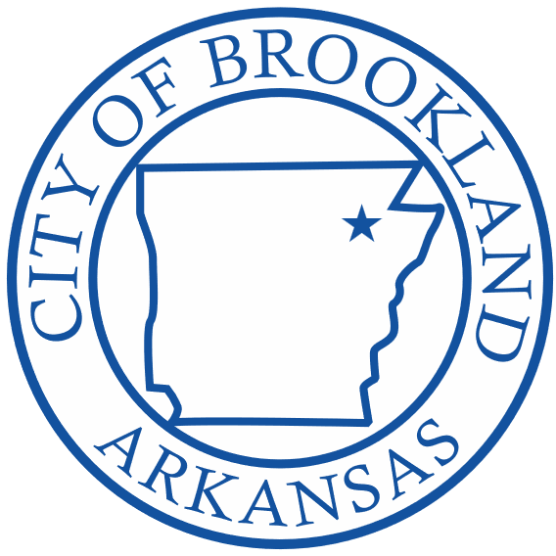
Brookland Parks Committee
613 Holman Street
Brookland, Arkansas 72417
Brookland City Hall

Date and Time of Meeting: 5/16/2022 6:05 PM
Type of Meeting: Regular

Committee Members Present: Justin Ladd, Julie Thomas, David Loggins, and Sharon Hopkins
Absent: Bobby Bishop
Others Present: Mayor Kenneth Jones, Ronnie Gilley

Meeting called to order at: 6:05 pm
Called by: David Loggins

Motion by: Justin Ladd
Second by: Sharon Hopkins
To: Approve meeting minutes from April 2022
Motion passed
For: 4
Against: 0

6:05 David Loggins opened the meeting with the copy of an email from Michael Moyers regarding naming rights for the Sports Plex, including wording that will be included in a naming rights contract. Naming rights for the Sports Plex, fields, dugouts, batting cages are all options. Discussion included pricing options for anything with the option for naming rights.

6:11 Discussion by Justin Ladd about where the architects currently are in the process of planning the parks. Mayor Jones said that possibly in one to two months, they will possibly be ready to begin advertising for dirt work. Mayor Jones included that the architect should be ready to present the committee with a timeline for construction processes in the near future.

6:15 Sharon asked about naming rights for different aspects of the park and what the cost for each would be. David Loggins mentioned that naming rights will depend on perpetuity and other variables.

6:22 Discussion about the current estimated costs of the Sports Plex and what all it includes.

6:26 David Loggins mentioned talking to Fisher & Arnold at the next meeting. He also mentioned their fees for the project of 7% of construction costs.

Motion by: Sharon Hopkins
Second by: Julie Thomas
To: Adjourn at 6:31 pm
Motion passed
For: 4
Against: 0

